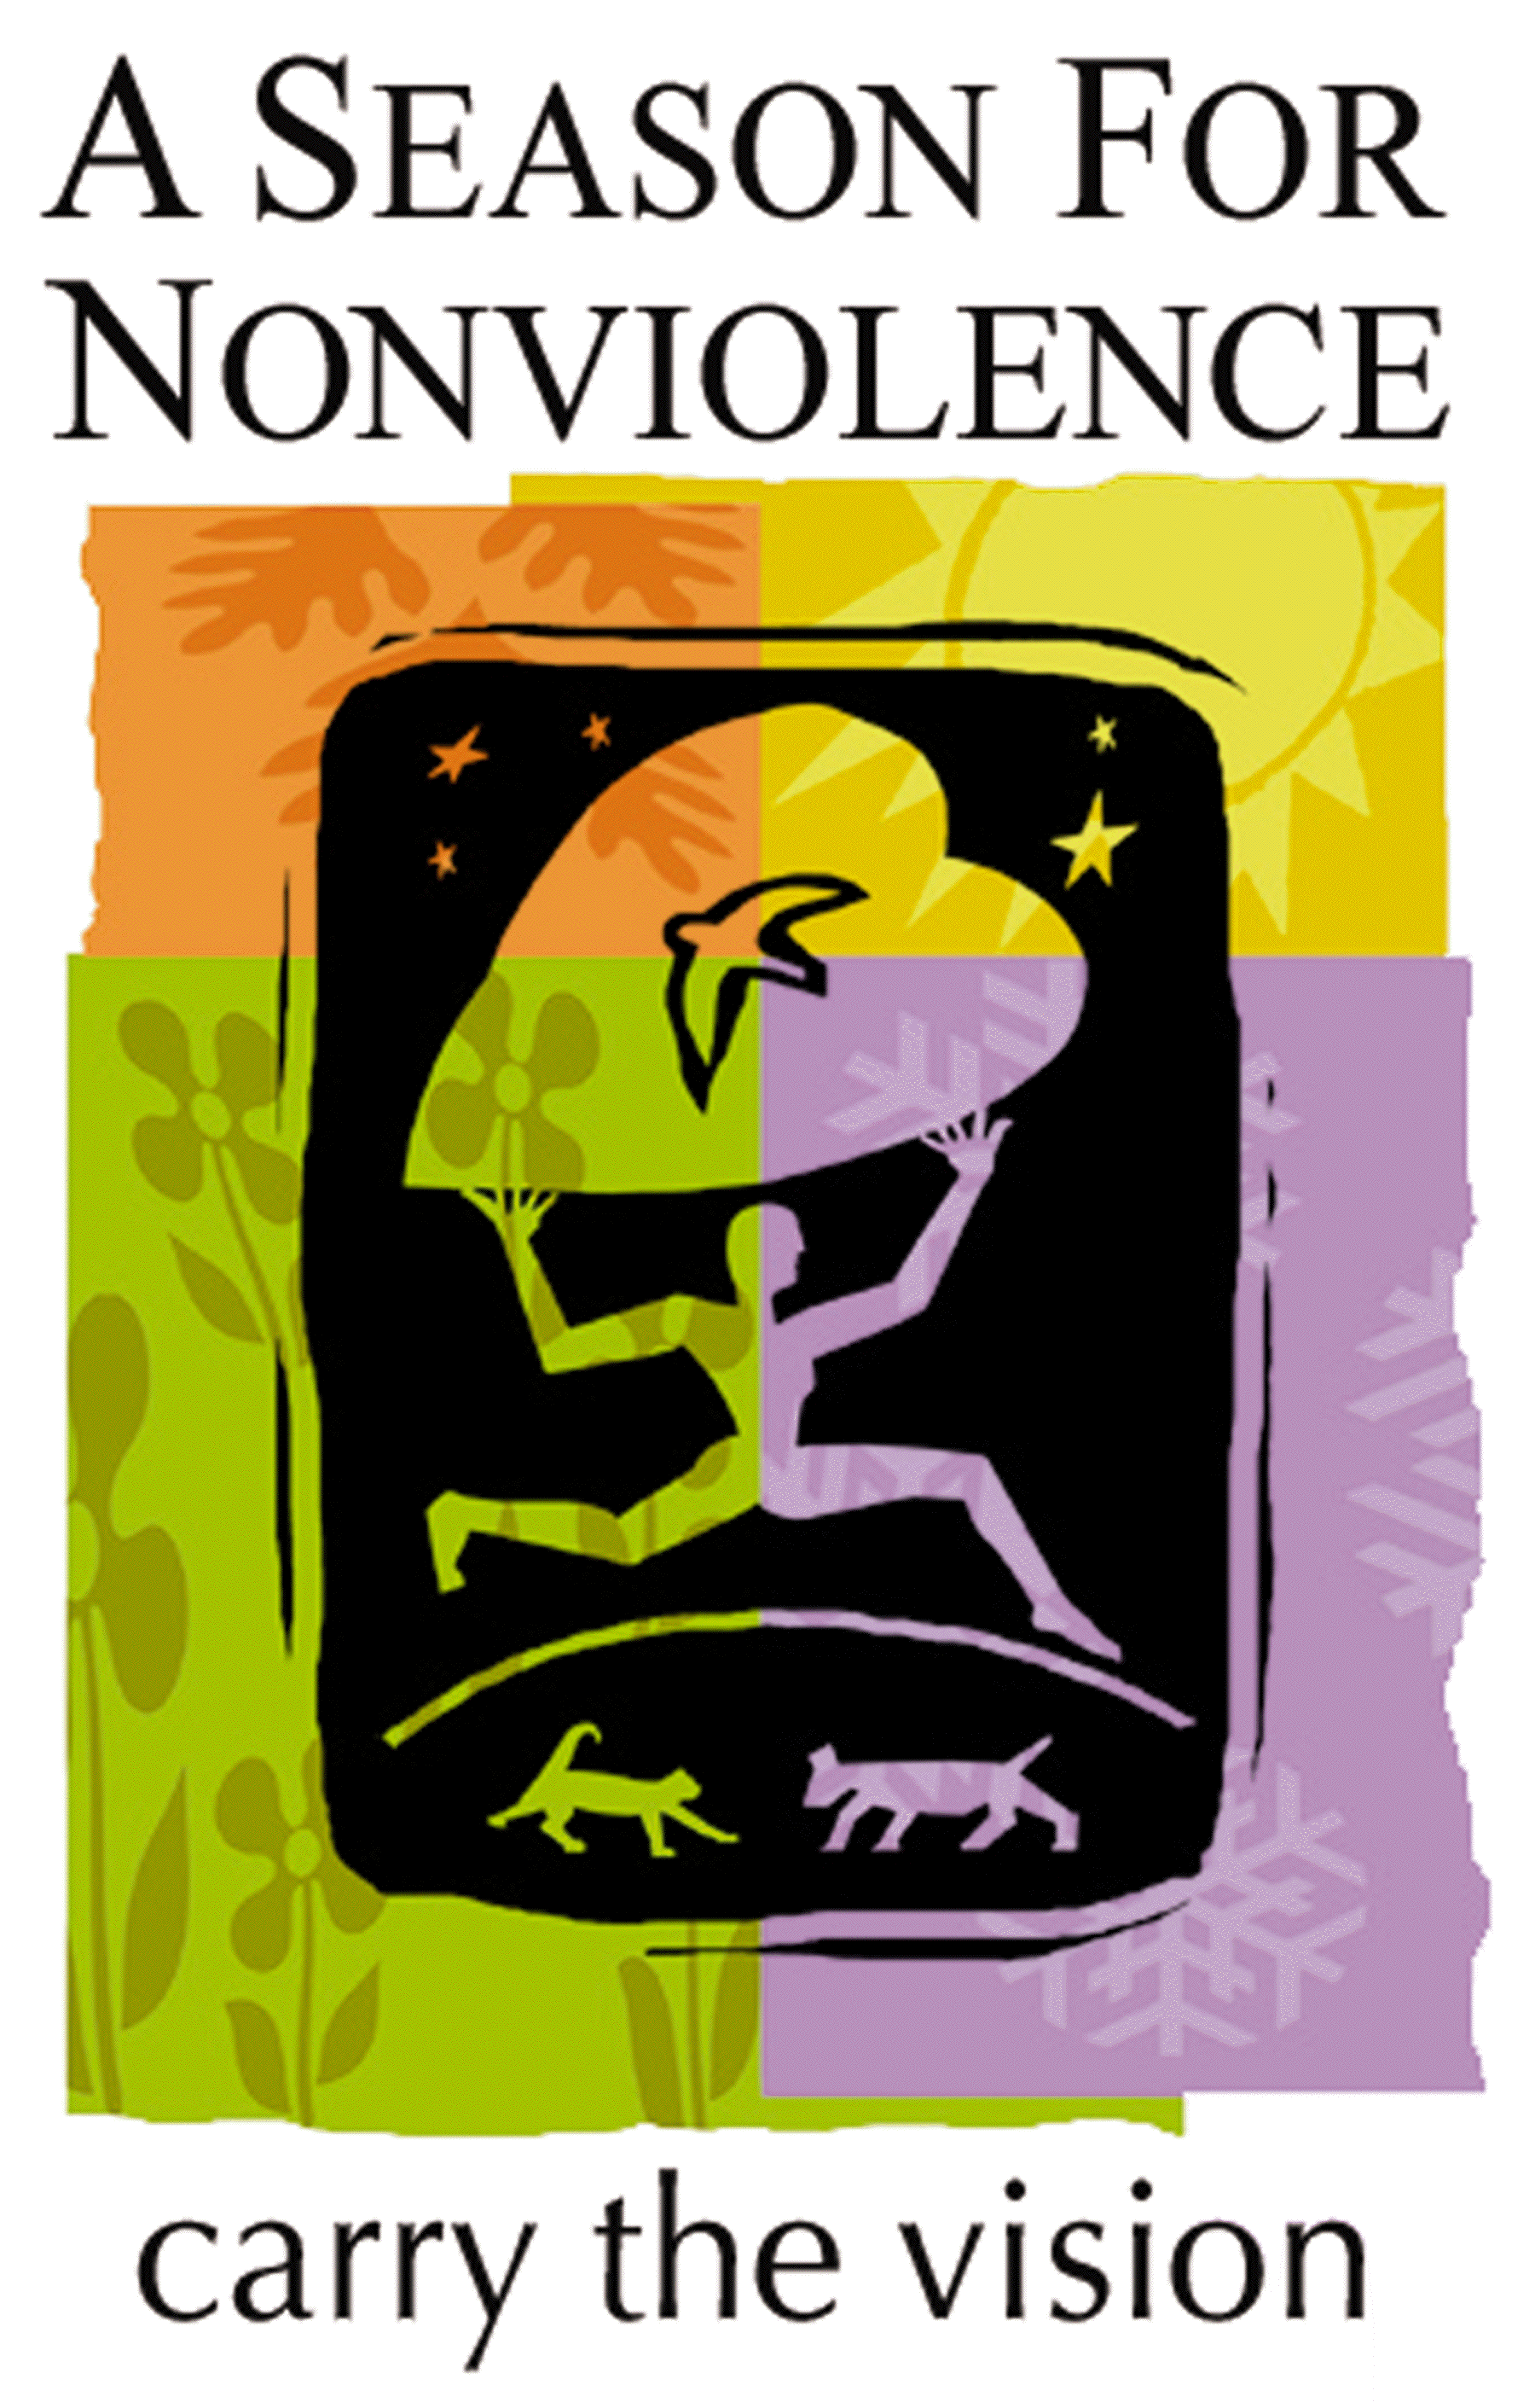

General Report on the Annual
GANDHI – KING – GYATSO SEASON FOR NONVIOLENCE
(1998-2015)

With the exemplary commitment of task force leaders and volunteers, the Season for Nonviolence (SNV), January 30- April 4, 1998-2015, has attained unanticipated goals in a 64 day educational, media and grassroots campaign inspired by the 50th and 30th memorial anniversaries of Mahatma Gandhi and Dr. Martin Luther King, Jr., now with the inclusion of Cesar Chavez whose family and contemporaries have carried on his great work.

The 18th Anniversary of A Season for Nonviolence

2015 marks the 18th anniversary of this revolutionary initiative. The Season for Nonviolence represents a successful new model called, “omni-local” conscious action:

“Engaging large numbers of self-empowered leaders and groups in a collective intention, supplied with strategic sharable tools, adding their own local resources to work globally with singular purpose.“

When SNV celebrated its 10th anniversary in 2007 with the “Gandhi King Peace Train and Living Legends of Nonviolence Conference,” it was a landmark that put nonviolence on the map in this century. A new model for spiritually-based peace governance had emerged, igniting entire communities everywhere.

The Season for Nonviolence project has now evolved through our collective, exemplary leadership in more than 900 cities in all U.S. States and 67 countries during the past fifteen years. The bookend memorial anniversaries of Gandhi (Jan 30) and Martin Luther King Jr. (April 4), and birthday of Cesar Chavez (March 31), brought us to the halfway point in our second decade of "Perennial Season," in which unwavering nonviolence in thought, emotion, word, and action has become our chosen way of life. Gyatso Tensin, known as the Dalai Lama was added to the leaders we honor during this Season.

A Season for Nonviolence was co-founded by Arun and Sunanda Gandhi of the M.K. Gandhi Institute for Nonviolence and a group of ten ministers forming the Leadership Council of The Association for Global New Thought, the organization that convenes A Season for Nonviolence on an annual basis. Its purpose, to focus educational and media attention on the philosophy of attaining peace through nonviolent action as demonstrated by Gandhi, Gyatso Tensin, Martin Luther King, Jr.

The Objectives
Our objective each year has been to create an awareness of nonviolent principles and practice as a powerful way to heal, transform and empower our lives and communities. Through an educational and community action campaign, we have recognized those who are using nonviolence to build a community that honors the dignity and worth of every human being. By identifying “what works” in these new models for reconciliation and human harmony, we are demonstrating that every person can move the world in the direction of peace through their daily nonviolent choice and action.

Overview of Results
Launching on the January 30th memorial anniversary of Mahatma Gandhi, A Season for Nonviolence draws to a close on each year on the King April 4th memorial, having seeded since 1998 substantial activity in over 900 cities in all 50 states, and 67 countries. At least fifty percent of our United States governors, and many mayors issued official proclamations for the 64 day period, and over three hundred unique events and programs have been developed and carried out at the local level during the Season. There are 87,000 web pages that refer to Season for Nonviolence. Media coverage includes radio and television broadcasts, PSA and film productions, and print publications at all levels from local to national press. At least 350 major Peace organizations, religious, business, arts, and learning institutions have elected themselves as official co-sponsors of the Season for Nonviolence initiative.

United Nations Launch-1998-2012
SNV was launched for the past fifteen years, beginning with the inaugural event in 1998, at the United Nations. These events brought forth substantive endorsements and commitments from the UN Secretary General, Kofi Annan, the U.S. Ambassador to India, Vice President Al Gore, and the Director General of UNESCO on behalf of its Culture of Peace AND NONVIOLENCE appeal by the Nobel Peace Laureates (language officially added as a result of the SNV inaugural year). Other notable speakers included Jesse Jackson, Dr. C.T. Vivian, and Dr. A.T. Ariyaratne of Sri Lanka. Concurrently on that date, task force leaders collaborated to create additional celebrations in other major cities. In general, A Season has received the written support of His Holiness, the Dalai Lama of Tibet, Coretta Scott King, Dr. Robert Muller, and many other serious and distinguished individuals from virtually all sectors of the world leadership community.

The Leadership
The Association for Global New Thought is the convener and co-founder of SNV under the chairmanship of Michael Bernard Beckwith, D.D. Charter co-founders are Arun and Sunanda Gandhi of the M.K. Gandhi Institute for Nonviolence. Partners are Anthony Chavez, grandson of Cesar Chavez, and Dolores Huerta, contemporary of Chavez and Director of the Dolores Huerta Foundation; Dr. Bernard Lafayette, former executive assistant to Dr. King and Director of the Center for Nonviolence & Peace Studies at the University of Rhode Island; Alison Van Dyke, Chairperson of the Temple of Understanding in New York; Dean Lawrence Carter of the MLK Jr. International Chapel at Morehouse College; Dean James Parks Morton of the Interfaith Center of New York, and Dr. Richard Deats of the Fellowship of Reconciliation. Co-founder and Project Director is Dr. Barbara Fields, Executive Director of the Association for Global New Thought, Program Director for the 1993 Parliament of the World’s Religions, and for the Synthesis Dialogues 1999, 2001, 2004 (with His Holiness, the Dalai Lama) in Dharamsala, India, Trent, Italy and Castelgandolfo, Rome).

